 | + | 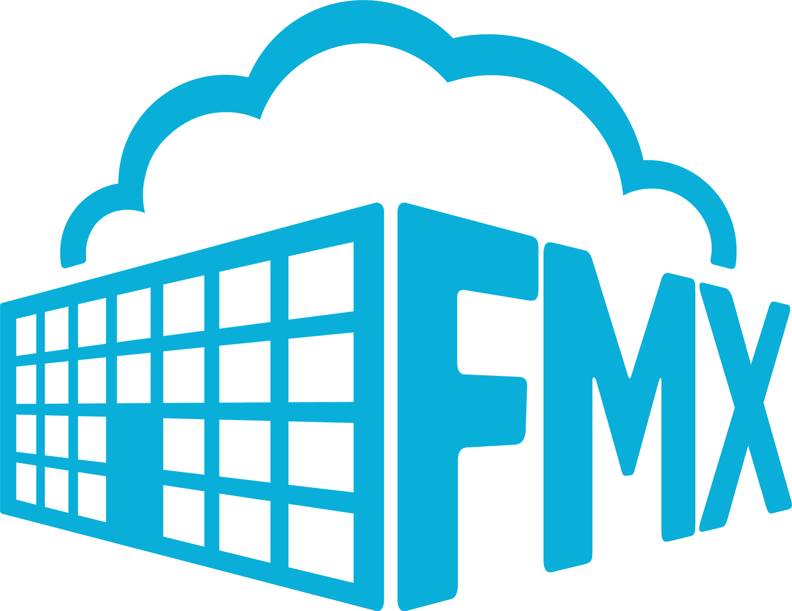
Hello Staff,
I'm excited to announce the new work order software that we will be using this year, FMX. This software will allow you to easily schedule work order requests. Our company-wide launch took place on March 1, 2022. For any questions regarding this transition, please contact Shawn Dahlen, sdahlen@goleta.k12.ca.us or Justina Dattilo, jdattilo@goleta.k12.ca.us.
Follow the instructions below to register for an account and log in:
- Open your internet browser (Chrome, Firefox, Internet Explorer, etc.) and navigate to https://goleta.gofmx.com/.
- Click the Staff Login button to log in with your gmail account.
- Check your email, a confirmation email will be sent to confirm your account. Click the confirmation link in the email to complete your account registration and log in to FMX.
Refer to these links for education on how to properly submit requests:
Click here to learn how to submit a Work Request.
If you ever forget your password, click here to learn how to reset your password.
If you run into any complications or have additional questions, contact Shawn Dahlen, sdahlen@goleta.k12.ca.us or Justina Dattilo, jdattilo@goleta.k12.ca.us or the FMX Customer Support Team at support@gofmx.com.
Thank you!

